Introduction
Air pollution has been linked to adverse effects on the human body, such as respiratory, cardiovascular diseases, oxidative stress, and inflammation (Sangkham et al., 2024). A recent study has also shown that exposure to air pollution was associated with increased risk of depression and anxiety (Yang et al., 2023). A key indicator of harmful air pollution is PM2.5, which is fine particulate matter with a diameter of 2.5 µm or less (C40 Knowledge Community, n.d.). Singapore is no exception to air pollution, having faced severe haze several times, and most recently in 2019, when haze from forest fires was blown in from southern Sumatra (Haze Situation Update (18 September 2019), n.d.). Studying PM2.5 patterns over time and across locations is useful for planning things like better allocation of health resources, targeted health messaging, and rules like halting outdoor activities to reduce the impact of air pollution.

Motivation
I selected two datasets for studying air pollution. One dataset is for annual mean PM2.5 by country and residence area type from 2010-2019, taken from World Health Organization (WHO). The other dataset is for hourly PM2.5 levels of North, South, East, West, and Central regions of Singapore from 2016 to 2024, taken from data.gov.sg. I wanted to compare the trends of PM2.5 levels over the years for several countries to see if air pollution is being tackled. I also wanted to see whether there were specific regions in Singapore that had higher levels of PM2.5 compared to other regions, to gain insights if there were any patterns to air pollution in Singapore. Having access to PM2.5 data on subgroups like the residence area types and regions in Singapore is also crucial in allowing clinicians and policymakers to know how to better allocate their health resources.

Macro Plot
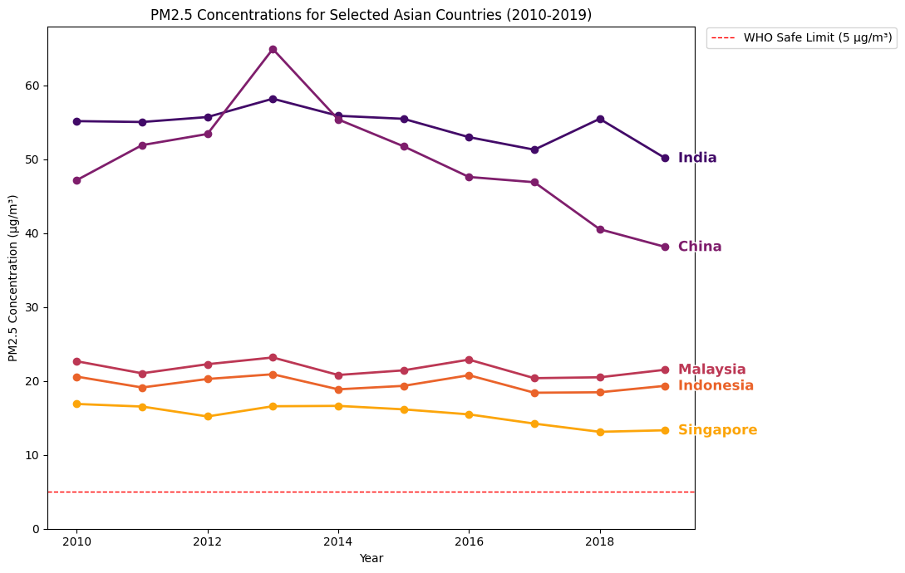
Dataset: https://www.who.int/data/gho/data/themes/air-pollution/modelled-exposure-of-pm-air-pollution-exposure
This macro plot shows the trend of annual mean PM2.5 concentrations across several Asian countries from 2010 to 2019. All 5 countries remain consistently above the World Health Organization (WHO) annual guideline for PM2.5 concentrations at 5µg/m³ (C40 Knowledge Community, n.d.). PM2.5 concentration levels in India and China are also approximately 2-3 times greater than Southeast Asian countries. I chose a multi-series line chart because I wanted to know whether the air pollution in countries is improving, stagnating, or worsening over time. For clinicians and policymakers, this plot gives insights into understanding which countries are at greater risk of adverse effects from air pollution. As for limitations, since this dataset is showing the PM2.5 value for an entire country, it doesn’t provide any information on specific cities, towns, urban or rural areas that may have hotspots. It also likely will conceal any short-term spikes since it is an aggregate.

Micro Plot
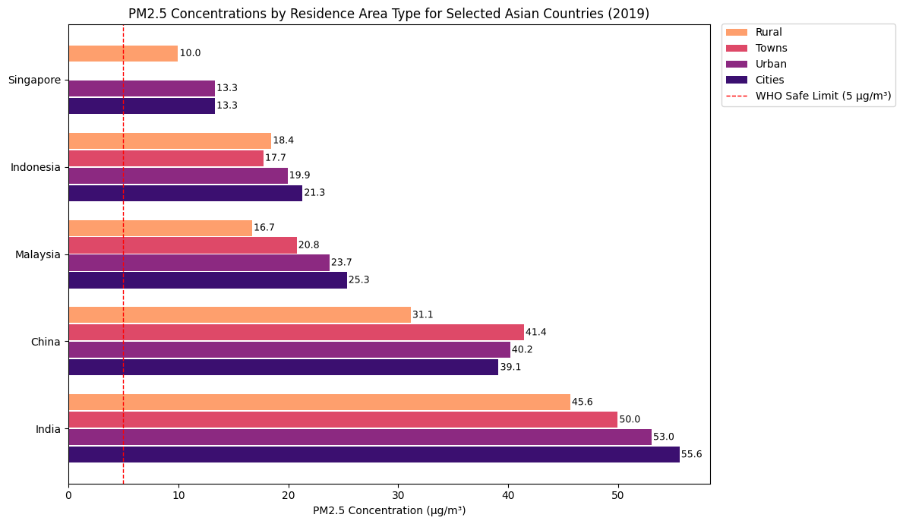
Dataset: https://www.who.int/data/gho/data/themes/air-pollution/modelled-exposure-of-pm-air-pollution-exposure
In this micro plot, I focused on the year 2019 and broke down each country’s PM2.5 values into residence area types (rural, towns, urban, and cities) as I wanted to know how PM2.5 levels differ by area type. I chose a grouped bar chart because it is easy to see the differences in PM2.5 levels between each area type in a country, and to see the differences in PM2.5 levels between each area type across countries. The bars are horizontal for label readability due to the length of the country names, which may overlap if placed on the x-axis. The WHO guideline line was also added as a reference for how far the countries exceed the safe limit. For clinicians and policymakers, this plot is more useful in comparison to the macro plot in terms of understanding which area types are more at risk, and where to focus resource allocation such as emission controls, outdoor activity advisories, etc. One of the limitations of this plot is that certain areas may not be evenly modelled, as it may be harder to monitor in one area type compared to another. For smaller countries like Singapore, it would be better to compare regional or neighbourhood-level PM2.5 levels for more precise targeting.
Actionable Plot
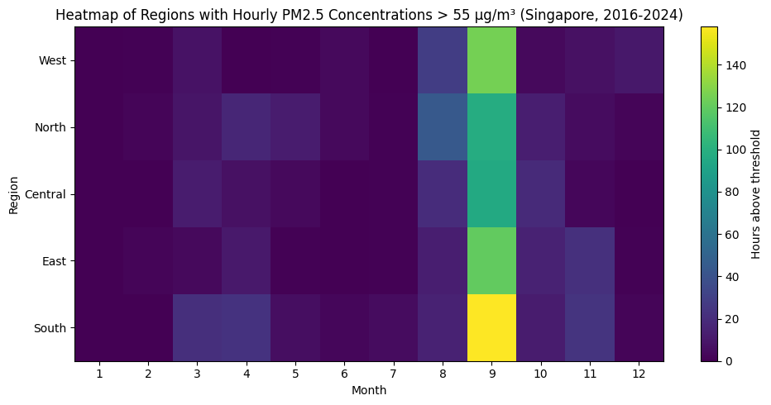
Dataset: https://data.gov.sg/datasets?q=&ext_type=dataset&groups=&organization=&query=pm2.5&resultId=2216
For the actionable plot, I summed the number of times in a specific (Month, Region) in Singapore when the hourly PM2.5 concentrations exceeded 55 µg/m³, which falls into the “Elevated” PM2.5 level (HAZE - the National Environment Agency, n.d.), from 2016 to 2024. I wanted to find out if there were specific regions or months where PM2.5 levels were more elevated compared to the rest. I used a heatmap as regions or months as risk are easily noticeable, where brighter regions highlight severe PM2.5 levels. Other than the entirety of September, the months 3,4, 8, 10, and 11 still has regions with noticable colouring on the heatmap, showing regions that could potentially be at risk, especially South and West. For clinicians and policymakers, this provides valuable information on how they could allocate health resources like respiratory medicines and advisory messages to counter the adverse effects of air pollution in certain regions. The main limitation is that the plot can be heavily influenced by abnormal events such as the haze in September 2019 caused by forest fires in Sumatra, Indonesia (Haze Situation Update (18 September 2019), n.d.). The plot should be used as a guide to plan resources rather than a forecast for how PM2.5 levels behave throughout the year in Singapore.
GitHub Repository
https://github.com/leeyanleryan/DSA4262/tree/main/Individual Assignment 1

Datasets
Modelled exposure to particulate matter air pollution. (2024, October 24). https://www.who.int/data/gho/data/themes/air-pollution/modelled-exposure-of-pm-air-pollution-exposure
Data.gov.sg. (n.d.). data.gov.sg. https://data.gov.sg/datasets?q=&ext_type=dataset&groups=&organization=&query=pm2.5&resultId=2216

References
Sangkham, S., Phairuang, W., Sherchan, S. P., Pansakun, N., Munkong, N., Sarndhong, K., Islam, M. A., & Sakunkoo, P. (2024). An update on adverse health effects from exposure to PM2.5. Environmental Advances, 18, 100603. https://doi.org/10.1016/j.envadv.2024.100603
Yang, T., Wang, J., Huang, J., Kelly, F. J., & Li, G. (2023). Long-term exposure to multiple ambient air pollutants and association with incident depression and anxiety. JAMA Psychiatry, 80(4), 305–313. https://doi.org/10.1001/jamapsychiatry.2022.4812
C40 Knowledge Community. (n.d.). https://www.c40knowledgehub.org/s/article/WHO-Air-Quality-Guidelines?language=en_US
Haze situation Update (18 September 2019). (n.d.). https://www.nea.gov.sg/media/news/advisories/index/haze-situation-update-18-september-2019
HAZE - the National Environment Agency. (n.d.). Default. https://www.haze.gov.sg/

